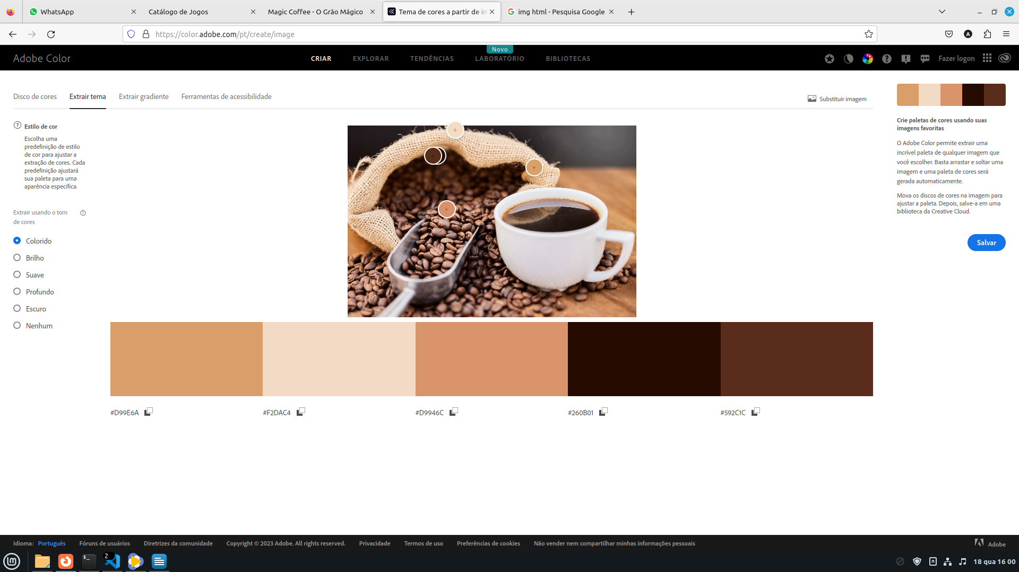

#D99E6A | #F2DAC4 | #D9946C | #260B01 | #592C1C